DEPARTMENT OF BIOTECHNOLOGY
ADD ON SKILL COURSE
GENERAL FOOD MICROBIOLOGY
30 HOURS
26 FEB, 24 – 6 APRIL, 2024
SYLLABUS:
WEEK 1-
- Food as a nutrient for various microorganisms
- Factors affecting the growth and survival of microorganisms in food
- General features and importance of different groups of bacteria, yeasts and molds important in food
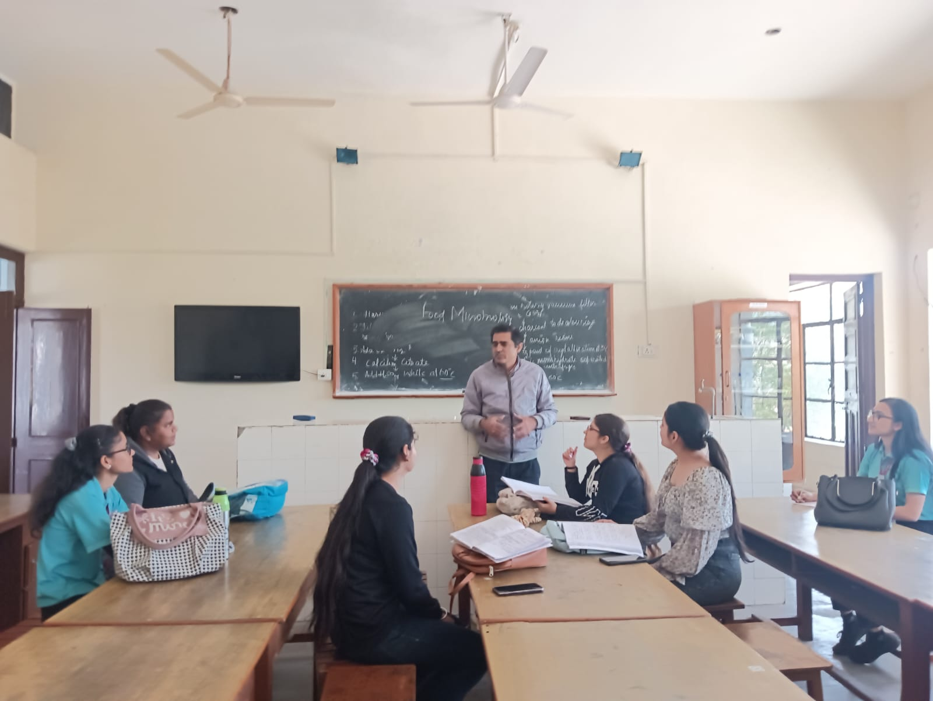

WEEK 2-
- Method of microbial examination of food
- Traditional and non-traditional methods for the examination of food and food products
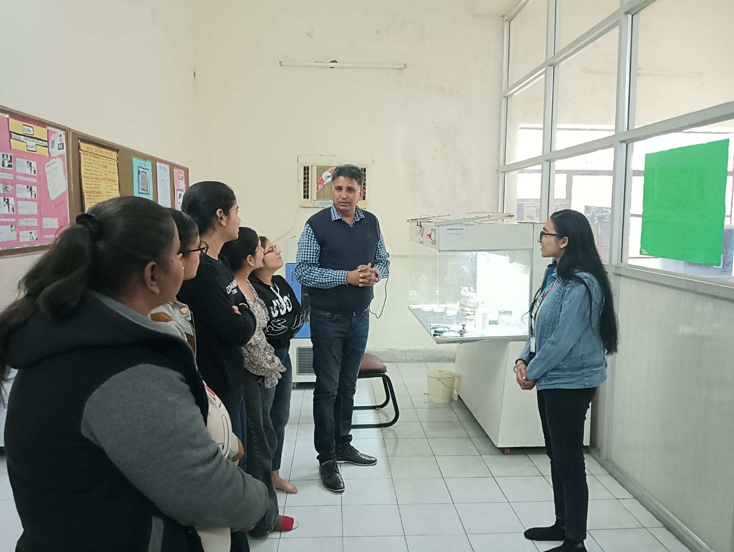

WEEK 3-
- Food spoilage- Microbial and Biochemical aspects of food spoilage
- Role of bacteria, yeast and molds in food spoilage.
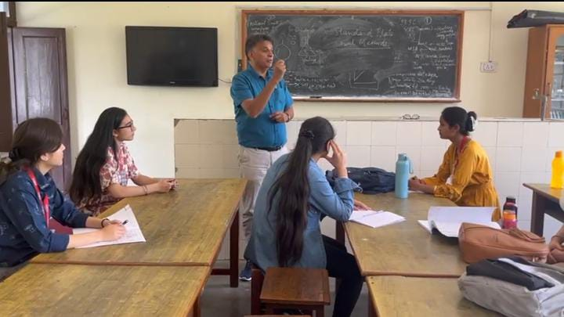

WEEK 4-
- Foodborne Illness
- Food intoxication and food infection
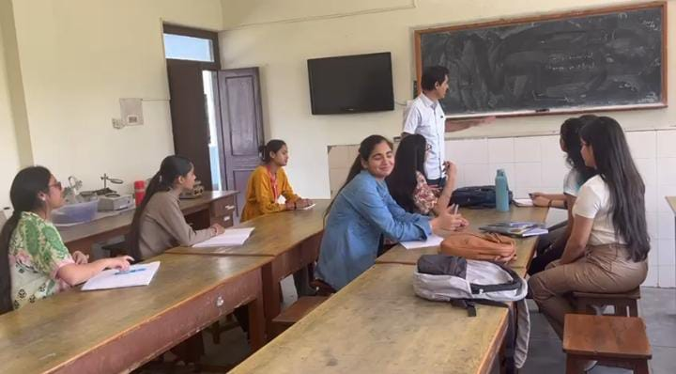

WEEK 5-
- Bacterial Food Poisoning by
    - Staphylococcus aureus
    - Clostridium botulinum
    - Salmonella
    - E. coli
    - Clostridium perfringens
    - Listeria monocytogenes
    - Campylobacter jejuni
- 